COPYMASTER |  |  | VERSION: 1.04
Project Name: Picanto_GG | Product Name: Acer Nitro V 16 AI | Product Type: Entry level gaming laptop
Writer: Clark Gurden | PMKT: Sylvia Pan | FCS: 3/30/26
Updates
Added xbox game pass related agw/A+ disclaimers and ksps
Changed NV content
- Reflex 2-> reflex and messaging
AI tops and laptop gpu same line
1.03
Change 12 cores to 10 cores in amd messaging
UNDER EMBARGO

AGW Meta Content
Page Title (60) | Acer Nitro V 16 AI | Copilot+ PC
Meta Description (160) | The Acer Nitro V 16 AI Copilot+ PC combines an AMD Ryzen™ AI 9 465 processor and NVIDIA® GeForce RTX™ 5070 Laptop GPU performance in a 16-inch form factor for gaming and study.
Product Card Description (120) | AI-ready performance meets mobile gaming power with AMD Ryzen™ AI 400 Series processors.

AGW Page Content
Product Name |  | Acer Nitro V 16 AI
Tagline (60)
Key Message/Page Intro
Key Message/Intro (220) |  | The Acer Nitro V 16 AI Copilot+ PC delivers serious gaming and AI performance. Powered by up to an AMD Ryzen™ AI 9 465 processor and NVIDIA® GeForce RTX™ 5070 Laptop GPU, it’s built for gaming, study, and everything between.
Copilot+PC/Windows Message |  | Copilot+ PCs are the fastest, most intelligent and secure Windows PCs ever.  Next-level you. Now with AI.
Logo |  | 
CTA Button |  | Watch Video
CTA Button Link |  | https://youtu.be/aZSq94Ldluo
Logos / Badges / Awards
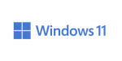 | 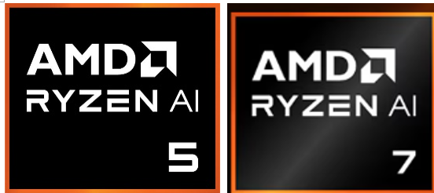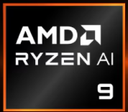 |  |  |  |  |  | AMD FreeSync |  | 
Media Reviews – ENGLISH (ENG)
Publish to USA / CA
Section Headline |  | Media Reviews
Text Content
Image Selection |  | Generic |  | Generic |  | Generic |  | Generic
Reviewer Name |  | Android Authority
Quote (180) |  | "For AMD fans, the most notable refresh at CES 2026 is the new Acer Nitro V 16 AI (ANV16-A71)"
Button & URL |  | Read More |  | Read More |  | Read More |  | Read More

Partner KSP 1
Image Ref |  | 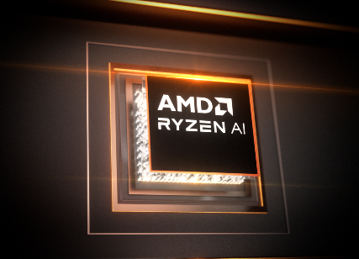
KSP Headline (40) |  | Every Task, Every Workflow, Elevated.
KSP Body (250) |  | Powered by up to 10 “Zen 5” cores, AMD Radeon™ 800M graphics, and a 50+ TOPS AI engine, AMD Ryzen™ AI 400 Series processors deliver intelligent multitasking, console-class visuals, and adaptive AI performance for creation, gaming, and productivity.
Overline (20) |  |  | Up to AMD | Up to | Up to
Spec (30) |  | Windows 11 Home | Ryzen™ AI 9 465 | 10 Cores / 20 Threads | 5.0 GHz
Underline (20) |  | Operating System | processor |  | Max Boost
Partner KSP 2
Tagline |  | Game Changer
Series Headline |  | GeForce RTX™ 50 Series Laptops
Tech Headline |  | Powered by NVIDIA Blackwell and AI
Overline (20) |  | Up to NVIDIA® |  | 5th Gen Tensor Cores
Spec (30) |  | GeForce RTX™ 5070 |  | Max AI Performance
Subline (20) |  | Laptop GPU (798 AI TOPS) |  | With FP4 & DLSS 4
Partner KSP 2.1
Image reference |  | 
Tech Headline |  | DLSS 4
KSP Headline |  | Supreme Speed. Superior Visuals. Powered by AI.
KSP Body |  | DLSS is a revolutionary suite of neural rendering technologies that uses AI to boost FPS, reduce latency, and improve image quality. ‌The latest breakthrough, DLSS 4, brings new Multi Frame Generation and enhanced Ray Reconstruction and Super Resolution, powered by GeForce RTX™ 50 Series GPUs and fifth-generation Tensor Cores. DLSS on GeForce RTX is the best way to play, backed by an NVIDIA AI supercomputer in the cloud constantly improving your PC’s gaming capabilities.
Partner KSP 2.2
Image reference |  | 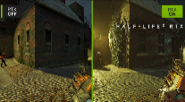
Tech Headline |  | Full Ray Tracing with Neural Rendering
KSP Headline |  | Game-Changing Realism
KSP Body |  | The NVIDIA Blackwell architecture unlocks the game-changing realism of full ray tracing. Experience cinematic quality visuals at unprecedented speed powered by GeForce RTX 50 Series with fourth-gen RT Cores and breakthrough neural rendering technologies accelerated with fifth-gen Tensor Cores.
Partner KSP 2.3
Image reference |  | 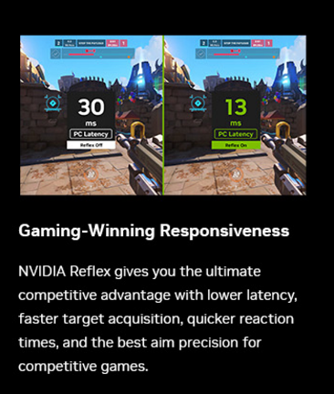
Tech Headline |  | NVIDIA Reflex
KSP Headline |  | Game-Winning Responsiveness
KSP Body |  | NVIDIA Reflex gives you the ultimate competitive advantage with lower latency, faster target acquisition, quicker reaction times, and the best aim precision for competitive games.
Partner KSP 2.4
Image reference |  | 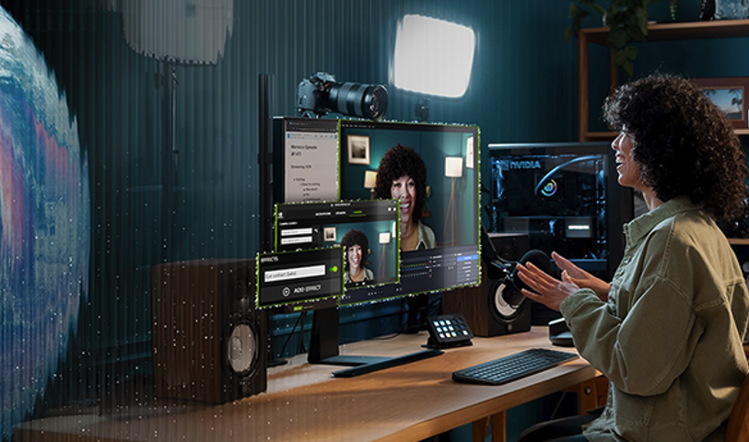
Tech Headline |  | RTX AI PC
KSP Headline |  | NVIDIA Powers the World’s AI. And Yours.
KSP Body |  | Upgrade to advanced AI with NVIDIA GeForce RTX™ GPUs and accelerate your gaming, creating, productivity, and development. Thanks to built-in AI processors, you get world-leading AI technology powering your Windows PC.
Partner KSP 2.5
Image reference |  | 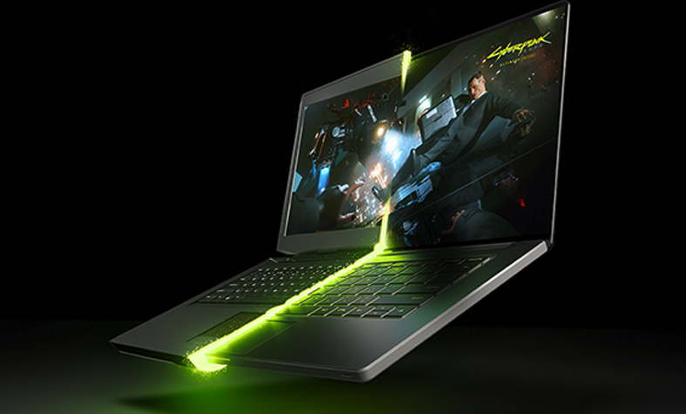
Tech Headline |  | NVIDIA Blackwell Max-Q
KSP Headline |  | Optimized Power and Performance
KSP Body |  | Max-Q is designed from the ground up for maximum efficiency, delivering a massive leap in performance and battery life.
KSP 1
Image reference |  | 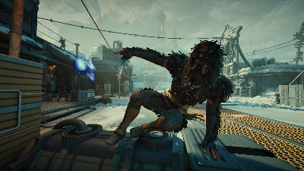
KSP Headline (40) |  | Visual Extravaganza
KSP Body (220) |  | Dive into smooth, detailed visuals on a 16-inch WUXGA (1920 × 1200) display with up to 180Hz refresh rate and 100% sRGB color coverage for gaming and creative work.
Overline (20) |  | Up to 16-inch | Up to | Up to
Spec (30) |  | WUXGA | 180Hz | 100% sRGB | MUX Switch
Underline (20) |  | 1920 x 1200 Display | Refresh Rate | Color Gamut | Equipped
KSP 2
KSP Headline (40) |  | Advanced Dual-Fan Cooling System
KSP Body (220) |  | Stay cool under pressure with dual-fan, dual-intake, and dual-exhaust cooling engineered for consistent thermal control during long gaming or productivity sessions.
KSP 3
Image reference |  | 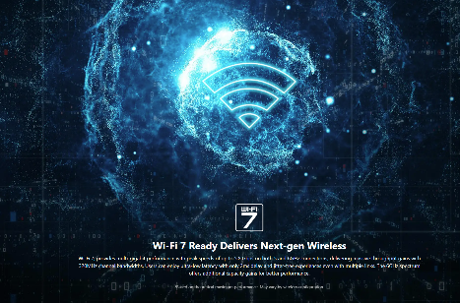
Logos (to be placed in main ksp graphic) |  | or   (choose one))
KSP Headline (40) |  | USB4 and Killer™ Ethernet
KSP Body (220) |  | Connect and compete with Wi-Fi 6E, Killer™ Ethernet E2600, and USB4 (Full Function) for faster transfers, smoother streaming, and reduced latency across every task.
KSP 4
IMAGE REFERENCE |  | 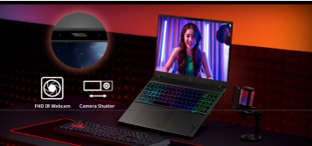  FOR RERENCE ONLY, CHANGE PC
KSP Headline (40) |  | Sharper Focus, Total Privacy
KSP Body (220) |  | The FHD IR camera keeps you clear and defined in every stream or team chat, while the camera shutter adds instant privacy when the match is over. Stay connected when it counts, unseen when it doesn’t.
KSP 5
KSP Headline (40) |  | Smart Control, One Touch
KSP Body (220) |  | Access NitroSense and Acer My Key for instant tuning and shortcuts with their designated keys. Manage cooling, lighting, and favorite apps without breaking your flow.
KSP 5.1
KSP Headline (40) |  | NitroSense
KSP Body (180) |  | Real-time control over fan speed and system performance for stable, optimized gameplay.
KSP 5.2
KSP Headline (40) |  | Acer My Key
KSP Body (180) |  | Customize quick-access shortcuts to open tools or apps instantly, saving time and clicks.
KSP 6
KSP Headline (40) |  | Acer Intelligence Space
KSP Body (180) |  | Launch smarter performance through Acer Intelligence Space, your hub for AI-ready tools and hardware insights that fuel productivity, creativity, and gaming
KSP 7
KSP Headline (40) |  | Discover Your Next Favorite Game
KSP Body (180) |  | Play hundreds of PC games with your new Acer Nitro Windows 11 PC and three months of PC Game Pass, including EA Play. With new games added all the time, there’s always something new to play.
GO LIVE 4/1/26
NEW MS PARTNER KSP 8 (US)
KSP Headline |  | Play 200+ Games on Your Windows 11 PC
KSP Body |  | Play The Outer Worlds 2, Forza Horizon 5, and 200+ more games on your new Acer Nitro Windows 11 PC with 2 months of Xbox Game Pass Premium. New Xbox published games join the library within 1 year of launch. Dive into a range of legendary franchises from Call of Duty to Minecraft and everything in between. Get in-game benefits for the biggest games like League of Legends, Call of Duty: Warzone, Rainbow Six Siege, and more. Play and earn up to $50 a year in the Store with Rewards. Find your community with Xbox and play anywhere you want
NEW MS PARTNER KSP 8 (WW)
KSP Headline |  | Play 200+ Games on Your Windows 11 PC
KSP Body |  | Play The Outer Worlds 2, Forza Horizon 5, and 200+ more games on your new Acer Nitro Windows 11 PC with 2 months of Xbox Game Pass Premium. New Xbox published games join the library within 1 year of launch. Explore a range of global franchises from Minecraft to Halo and everything in between. Get in-game benefits for the biggest games like League of Legends, Call of Duty: Warzone, Rainbow Six Siege, and more. Play and earn up to 50,000 points per year with Rewards. Find your community with Xbox and play anywhere you want.
Disclaimers
 | This product is not designed for cryptocurrency mining uses. Damages to your product arising from cryptocurrency mining or related activities are excluded from your product’s warranty.
 | The terms HDMI and HDMI High-Definition Multimedia Interface and the HDMI Logo are trademarks or registered trademarks of HDMI Licensing Administrator, Inc. in the United States and other countries.
 | Specifications may vary depending on model and/or region. All models subject to availability.
 | © 2026 Advanced Micro Devices, Inc. All rights reserved. AMD, the AMD Arrow logo, Radeon, and Ryzen and combinations thereof are trademarks of Advanced Micro Devices, Inc. Certain AMD technologies may require third-party enablement or activation. Supported features may vary by operating system. Please confirm with the system manufacturer for specific features. No technology or product can be completely secure.
 | The frequency of cores and core types varies by workload, power consumption and other factors. Visit https://www.intel.com/content/www/us/en/architecture-and-technology/turbo-boost/turbo-boost-technology.html for more information.
 | Max boost for AMD Ryzen processors is the maximum frequency achievable by a single core on the processor running a bursty single-threaded workload. Max boost will vary based on several factors, including, but not limited to: thermal paste; system cooling; motherboard design and BIOS; the latest AMD chipset driver; and the latest OS updates.
 | ©2026 NVIDIA Corporation. NVIDIA, the NVIDIA logo, GeForce, and GeForce RTX are registered trademarks and/or trademarks of NVIDIA Corporation in the United States and other countries. All other trademarks and copyrights are the property of their respective owners.
 | Memory limits depend on the OS. For details on Windows 11 Home and other versions, visit Microsoft Learn: https://learn.microsoft.com/en-us/windows/win32/memory/memory-limits-for-windows-releases.
 | Features and availability of Acer Intelligence Space (AIS) vary by model and region. Some functions require an active internet connection, supported hardware (such as an NPU or specific GPU), and future software updates. Performance may vary depending on system configuration
 | PC Game Pass: Subscription continues automatically at regular monthly price unless cancelled. Subject to xbox.com/subscriptionterms. Terms and exclusions apply. Game catalog varies over time, by region, and by device. All rights reserved. xbox.com/pcgamepass, ea.com/ea-play/terms. (above disclaimer is from the FY25 Xbox marketing guideline for your reference)
Xbox game pass US disclaimer (go live on 4/1/26)
 | Claim within 30 days of device activation. New and eligible returning members only. Valid payment method required. Subscription continues automatically at regular monthly price unless cancelled. Subject to xbox.com/subscriptionterms. New Call of Duty titles will join the library at least 12 months after launch. Benefits vary by Xbox Game Pass plan. Game library varies over time, by region, device, and Xbox Game Pass plan. xbox.com/gamepass. In-game benefits vary by game, region, and over time. Game must be installed to access in-game benefits. Xbox Cloud Gaming requires an Xbox Game Pass subscription and supported device (both sold separately). Cloud playable games not included with Xbox Game Pass are sold separately, and may be made available with Xbox Game Pass in the future. See library: xbox.com/play. Stream directly on Xbox consoles, or with the Xbox app or at xbox.com/play on supported devices. Select regions (xbox.com/regions) and devices (xbox.com/cloud-devices). Rewards: Terms apply. Microsoft Account required. Select markets only. Rewards vary by Game Pass Plan and Rewards Level. Point values vary by local market currency, Rewards level, and the number of points redeemed. Point multipliers compared to Game Pass Essential earning potential. Gameplay rewards for 18+. Exclusive quests with Premium and Ultimate plans only, for titles in the Game Pass library. Qualifying purchases at Microsoft Store (online, or on Windows or console) at Rewards with Xbox.

